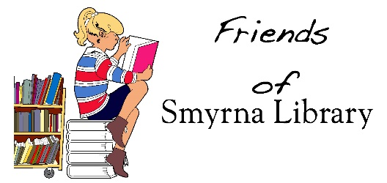
Friends of Smyrna Library
2024 Board of Directors

Theresa Pickett-President
Molly Jennings-Vice President
Bart King-Treasurer
Lysa Rigo-Secretary
Dre Bessone
Becky Carter
Katie Clark
Lezlie Fry
Jay Goslee
Michael Hendrickson
Kayce Howard
Molly Jennings
Dianne Reisdorf

